**Patient Group Direction management of delivering medication to patient HIV and GUM Directorate Chelsea and Westminster Hospital.line** or telephone consultation with patient documented on electronic notes.

**Patient assessed as eligible for treatment under Patient Group Direction.**

* 1. Check correct Name, telephone number, postal address and GP details
  2. Document that patient consents to having treatment posted to them

**At earliest convenient time collect drugs and padded posting envelope and check**

* 1. Correct patient
  2. Correct Drug
  3. Correct address
  4. Patient information/MHRA leaflet
  5. Document action in patient’s notes and document on locally held log that medication sent for patient delivery noting date, patient name drug signatures of Patient Group Direction user and Royal Mail reference code.

**Prepare medications for postage**

* 1. Clearly write patients name and full address in using black marker or print out Name and address from Lillie
  2. Obtain two ‘confidential stickers’ or use stamp and place on front and back of envelope
  3. Use Royal Mail Recorded Delivery Sticker
     1. Affix to front of package.
     2. Peel off the last barcode on the sticker and affix it to the locally held log

**Take envelope to the:**

* 1. Hospital Post Room ( open 8 am to 4 pm) or
  2. Local internal mail box to be collected and taken to the Hospital Post Room.

**Ensue contact with patient in 5 working days and document if drug received.**

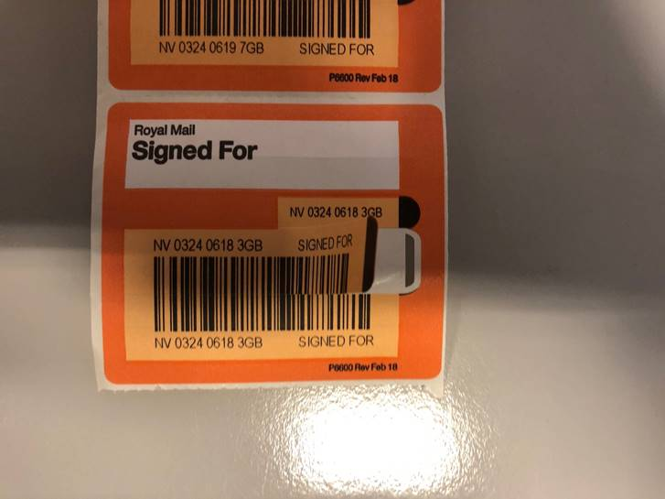

Keep for local records

Affix to back of envelope

Affix to front of envelope

Affix to central clinic log

|  |  |  |  |  |  |
| --- | --- | --- | --- | --- | --- |
| **Record of medication posted to patient: Clinic _______________________** | | | | | |
| **Date** | **Patient** | **Drug** | **PGD User** | **Barcode** | **Follow up call in 5 working days** |
|  |  |  |  |  |  |
|  |  |  |  |  |  |
|  |  |  |  |  |  |
|  |  |  |  |  |  |
|  |  |  |  |  |  |
|  |  |  |  |  |  |
|  |  |  |  |  |  |
|  |  |  |  |  |  |
|  |  |  |  |  |  |
|  |  |  |  |  |  |